SCHOOL OF NATURAL AND APPLIED SCIENCES
DEPARTMENT OF COMPUTER SCIENCE AND INFORMATION TECHNOLOGY (CSIT)
PROJECT - NPRJ740
ADVANCED ICT DIPLOMA - 2026
SUPERVISOR: DR TITE TUYIKEZE

PHASE 1
ICT Problem Identification and Solution Analysis

Field | Details
Name of Document | Phase 1: ICT Problem Identification and Solution Analysis
Name of the System | AgroAdvisor - an AI-assisted farm advisory platform for smallholder farmers
Student Name | [Student name]
Student Number | [Student number]
Submission Date | [Confirm submission date with the supervisor]

Yellow-highlighted text marks content that still needs real evidence or a personal detail from the student.

TABLE OF CONTENTS
1. Introduction 3
1.1 Background 3
1.2 Problem statement 3
1.3 Proposed solution 4
1.4 Unique value proposition 4
1.5 The business 5
1.6 ICT usage in the business 5
2. Identification of ICT Problems 6
2.1 Interview of the owner or employee 6
2.2 Daily transactions of the business 6
2.3 System and software requirements analysis 7
2.4 Use case diagram 7
2.5 Solution analysis 9
3. Conclusion 9
Appendix A: Interview Questionnaire 10
Appendix B: Technologies referenced 11
Appendix C: References 12

1. Introduction

1.1 Background
Small-scale farmers grow food for their households and their local communities. They work with little money, little spare land and few safety nets, so one failed season can take away both their food and their income. Statistics South Africa's Census of Agricultural Households counted 2,463,429 agricultural households in 2022, 13.8% of all households [7]. By comparison, the Census of Commercial Agriculture counted 40,122 commercial farming units in 2017 [8]. The two counts use different definitions, but they show that households farming on a small scale are the great majority of South African agricultural producers by number.
A very strong El Niño is now developing. The World Meteorological Organization (WMO) reports that El Niño conditions are strengthening and will persist at least into early 2027, with high confidence in that outlook [1]. The South African Weather Service (SAWS) states that the event is likely to become the strongest in living memory, that below-normal rainfall and above-normal temperatures are the most likely outcome for most of South Africa from October 2026 to January 2027, and that 2027 is likely to be the warmest year on record [2].
The same sources give an important limit. Not every El Niño causes drought: the very strong 1997/98 event brought slightly above-normal rain to parts of South Africa's summer rainfall region, and SAWS says uncertainty remains about the final strength and regional impact [2]. WMO adds that the strength of an El Niño alone does not decide how severe its impact is in a particular place [1]. This project therefore treats El Niño as a serious and likely risk to prepare for, not as a certainty.
There is a recent warning from the past. In the 2015/16 El Niño the national maize crop was forecast about 47% below the five-year average, with the drought centred on the Free State and North West provinces [4]. For 2026/27 the Department of Agriculture warns that heat and dry conditions often lead to crop failure and livestock deaths, especially where risk-reduction measures are not in place, and asks farmers to prepare in advance [3].
Food prices give a window to prepare, not a reason to relax. Annual food inflation fell in July 2026 to its lowest level in more than 16 years. Even so, an analyst quoted by Farmer's Weekly cautions that weather will become the most important factor for grain production and prices in the coming months, and low inflation does not mean food is affordable for every household [5]. A poor season could therefore quickly change today's picture.

1.2 Problem statement
Small-scale farmers must decide when to plant, irrigate, shade, shelter animals and harvest, but the information they can easily reach does not help them make those decisions for their own farm. General weather apps and broadcasts show the weather without saying what it means for the crops and animals on a particular farm. Advice from extension services is valuable but is not available to every farmer every day. In one Eastern Cape study, 80.2% of 126 extension practitioners had never received formal or informal climate-change training [6]. The same study found that 60.3% of practitioners prefer interpersonal channels, such as visits and farmer-to-farmer contact, over mass media and ICT [6]. AgroAdvisor is therefore designed to support extension officers and farmer networks, not to replace them.
In a very strong El Niño season this gap is costly. A farmer who does not know which days bring severe heat, which nights bring frost, or when heavy rain or wind is due cannot act in time, and a farmer who is new to farming has even less experience to fall back on. The assumption that many new small-scale farmers start with little farming experience is the author's hypothesis. It is not claimed as a research finding and is tested in the interview in Section 2.1.
The problem to solve is therefore: small-scale farmers lack timely, farm-specific, easy-to-understand guidance on when severe weather is coming and what to do about it, at a time when a harmful season is likely.

1.3 Proposed solution
AgroAdvisor is a farmer-only web application. It is not just a weather display. It reads each farmer's farm profile (location, crops and livestock), compares the forecast with agronomic thresholds, and tells the farmer what is coming and what to do. Its aim is to help small-scale farmers prepare for hard seasons and farm better, so they can keep producing food for their households and communities and recover from a bad season on their own strength.
What the farmer needs | How AgroAdvisor responds | Status
To know which days bring danger | A 7-day farm outlook with a risk note on each day for heat, frost, heavy rain, strong wind and storms | Built
To know what to do, when and why | A warning with a plain action, the date and the reason, and a voice option for farmers who prefer to listen | Built
To get advice in their own language | Interface in English, Afrikaans, isiZulu, Sesotho and Setswana | Built
To learn how to farm better | Short video lessons with key steps | Built
To learn from their own seasons | A private farm memory for events and plantings | Built
To use local knowledge | Moderated community notes about local conditions | Built
To prepare weeks or months ahead | Advice for the months of a season, using the official SAWS seasonal outlook | Planned, not built

At present the system gives day-by-day guidance for the next seven days. Month-by-month preparation, such as which months to plan for high heat, depends on seasonal forecasts and is listed as planned future work. It is not claimed as a feature of the current version. AgroAdvisor also does not promise higher yields: it supports better decisions, and results will still depend on rainfall, soil, water and the farmer's own work.

1.4 Unique value proposition
"AgroAdvisor turns the forecast into a plan for your own farm. It tells you what to do, on which day and why, in your own language, and then helps you learn and keep a record so that you farm better season after season."
What makes it different | Why it matters to a small-scale farmer
Advice is tied to the farm's own location, crops and livestock | The same forecast means different things for a maize field and for a goat herd
Every warning gives action, timing and reason | A farmer can act before the damage, not only read a number
Mobile-first design, five languages and voice warnings | Built for phones, slow data and farmers who prefer listening to reading
Advice, learning, farm memory and community notes in one place | The farmer does not need several tools to move from warning to action to learning
Runs on free-tier services | Keeps the cost of running it low, which suits a community-focused project

To check how distinctive this is, the features of other farmer apps were compared using a published list of mobile apps for South African farmers [9]. The descriptions below are as that article states them. The products were not installed or tested for this project.
Product (as described in [9]) | What it offers | What AgroAdvisor adds
Weather SA | Forecasts for temperature, rainfall and wind, and alerts about storms or droughts | Interprets the forecast for the farmer's own crops and livestock, with action, timing and reason
Farmers Weekly | News, expert advice and market trends | Daily, farm-specific guidance rather than general articles
WeFarm | Peer-to-peer questions and answers in the farmer's preferred language | Moderated notes tied to a 25 km area, plus structured warnings
AgriCloud and FarmBook | Farm and record management with weather forecasts | Focus on interpretation and risk warnings for a small farm, free to run

This comparison shows AgroAdvisor combining interpretation, warnings, learning, farm memory and local language in one product aimed at small-scale farmers. It does not prove that no similar product exists, and it does not claim that AgroAdvisor is better at forecasting than the weather services.

1.5 The business
The "business" assessed in this project is the small-scale farm. The target users are small-scale farmers such as those in and around Kimberley and the wider Northern Cape who grow vegetables and field crops and keep a few animals. The project is a general application domain, not a single registered company. The findings are therefore built around a representative small-scale farm, and the interview in Section 2.1 is intended to confirm them with real farmers.
A typical farm of this kind has one owner who is also the main worker, a small area of land, a few crops, and some livestock such as cattle, goats or poultry. Income depends on weather, water, and the owner's own decisions about what to plant, when to irrigate and how to protect crops and animals.

1.6 ICT usage in the business
The table below records the ICT tools a small-scale farmer might use today. The middle column is the working assumption used to design the system. It must be confirmed or corrected during the interview.
ICT area | Working assumption to be confirmed | Status
Communication | Mobile phone for calls and messaging | [Confirm in interview]
Weather information | General weather apps, radio or television forecasts that are not tied to the farm's own crops and animals | [Confirm in interview]
Record keeping | Paper notes or memory; no structured digital farm record | [Confirm in interview]
Learning and advice | Word of mouth, neighbours and occasional extension-officer visits | [Confirm in interview]
Internet access | Mobile data that may be slow and costly | [Confirm in interview]

2. Identification of ICT Problems

2.1 Interview of the owner or employee
Interview status: [NOT YET CONDUCTED. Replace this section with the real interview findings.]
No farmer has been interviewed at the time of writing, so this document does not report any interview results. Appendix A contains the interview questionnaire that will be used. After the interview, record each answer in the table below and write the problems it reveals.
Topic | Question asked (see Appendix A) | Interviewee's answer | Problem identified
Farm profile | Q1-Q4 | [Record answer] | [Problem]
Weather and risk | Q5-Q9 | [Record answer] | [Problem]
Advice and learning | Q10-Q13 | [Record answer] | [Problem]
Record keeping | Q14-Q16 | [Record answer] | [Problem]
Technology and language | Q17-Q21 | [Record answer] | [Problem]

Interviewee details: [Name or code, role (owner or employee), farm location, date of interview].

2.2 Daily transactions of the business
Interview status: [Observation or interview needed to confirm each row.]
A smallholder farm does not process sales transactions in the way a shop does. Its daily transactions are the decisions and tasks that the owner repeats every day. The table lists them with the potential ICT problem for each. The problems are hypotheses that come from the project's design brief and must be validated by monitoring a real farm for at least one day.
Daily task | Current method [[confirm]] | Potential problem (hypothesis)
Check the weather before work | Radio, TV or a general weather app | Weather is shown but not interpreted for the farm's crops and animals
Decide whether to irrigate or protect crops | Experience and guesswork | Frost or heat risk may not be recognised in time
Look after livestock (feed, water, shelter) | Routine and observation | Animals may not be moved to shade or shelter before severe weather
Record what was planted or what happened | Memory or paper | Past events and what worked are forgotten or lost
Find out how to solve a farming problem | Neighbours or extension officer | Advice is hard to reach and rarely in the farmer's own language
Learn about local hazards (flooding, frost pockets) | Local knowledge, not recorded | Useful local knowledge is not shared with nearby farmers

2.3 System and software requirements analysis
The problems above point to one gap: the farmer has data and experience but no tool that connects the weather forecast to the specific farm and says what to do about it. The need for a system follows from four requirements.
- Interpret the forecast against the farm's own location, crops and livestock, and produce plain-language advice and warnings, not just raw weather.
- Keep a private record of the farm (profile, events, plantings, what worked, lessons completed) so the farmer can see patterns over a season.
- Give short, practical learning material for small-scale farmers that loads lightly on slow connections.
- Let nearby farmers share local observations such as flooding or frost, clearly labelled as farmer-reported and not as researched advice.
The software requirements that these needs create are:
Need | Software requirement | Where it is met
Farm-specific advice | Store the farm profile; fetch the 7-day forecast; apply agronomic rules held in a knowledge base; show warnings | UC2, UC3, UC4
Secure personal data | Each farmer signs in and can read and write only their own data | UC1, UC2, UC7
Learning | Curated, reviewed video lessons with short summaries and key steps | UC5, UC6
Farm history | Dated records and a weekly summary | UC7
Local knowledge | Map notes with reporting and automatic hiding after two reports | UC8, UC9
Accessibility | Mobile-first interface in several languages | UC10

2.4 Use case diagram
The system has one type of user, the farmer. There are no administrator or buyer roles. The diagram shows the functions that are built in the system and the external services each one depends on.
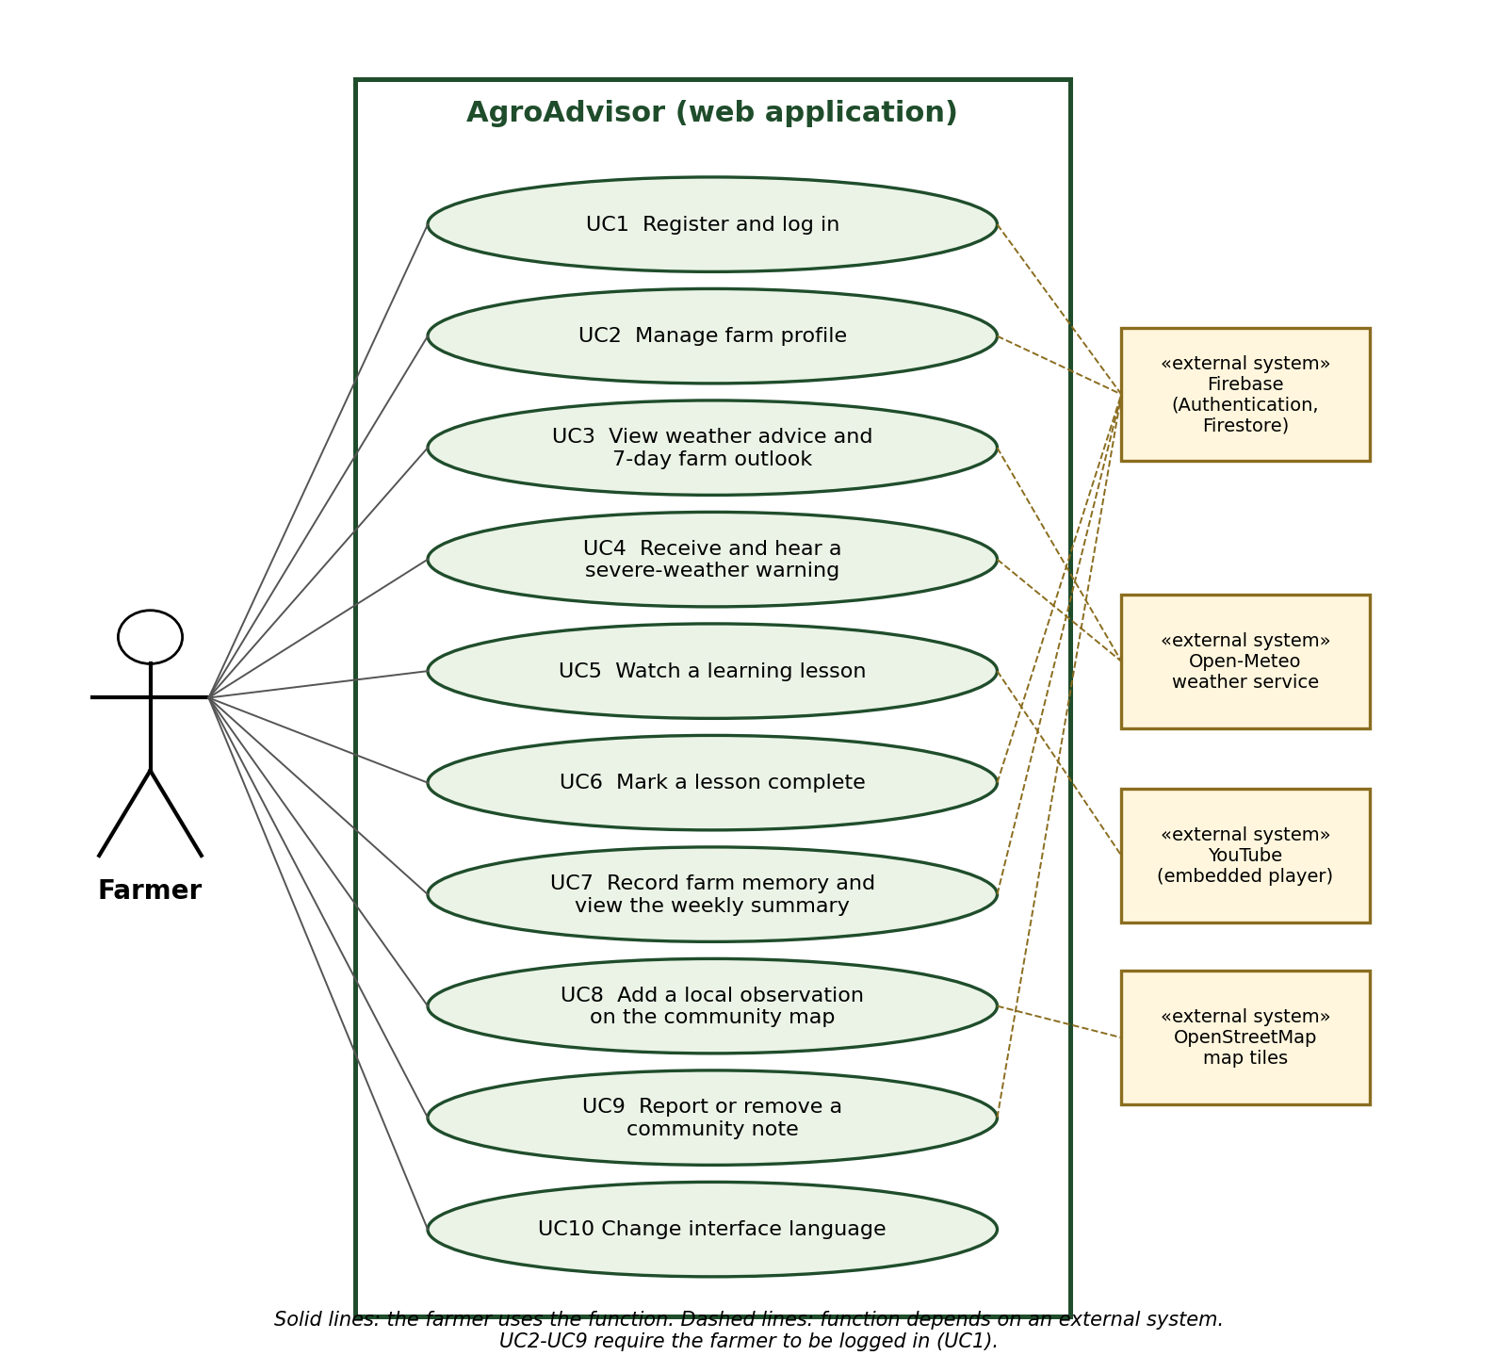
Figure 1: Use case diagram for AgroAdvisor
ID | Use case | Brief description
UC1 | Register and log in | A farmer creates an account or signs in with email and password or a Google account.
UC2 | Manage farm profile | The farmer enters the farm name, nearest town, map location, size, crops and livestock, and can edit them later.
UC3 | View weather advice and 7-day farm outlook | The system shows current conditions and a seven-day outlook with risk flags for the farm.
UC4 | Receive and hear a severe-weather warning | A warning pop-up shows the hazard, date and a short action, and can be read aloud.
UC5 | Watch a learning lesson | The farmer opens a lesson, reads the summary and key steps, and plays the embedded video.
UC6 | Mark a lesson complete | The farmer records that a lesson is finished. It also appears in farm memory.
UC7 | Record farm memory and view the weekly summary | The farmer saves weather events, plantings and what worked, and sees the current week.
UC8 | Add a local observation on the community map | The farmer places a pin within 25 km of the farm with a short note.
UC9 | Report or remove a community note | Another farmer can report a note. After two different reports it is hidden. Authors can remove their own notes.
UC10 | Change interface language | The farmer chooses English, Afrikaans, isiZulu, Sesotho or Setswana for the interface.

2.5 Solution analysis
Four ways of addressing the problem were compared. The ratings are the author's reasoned judgement from the project constraints and have not been tested with farmers.
Option | Strengths | Weaknesses | Fit
A. Existing general weather apps | Free and familiar | Show weather only; no farm profile, no advice, no farm record | Low
B. SMS or WhatsApp broadcast service | Works on basic phones; low data use | Messages are generic, not personal to the farm; needs a paid gateway; no history or learning | Medium
C. Extension officer visits | Expert, personal advice | Officers cannot reach every farmer every day; no continuous warning | Medium
D. AgroAdvisor web application (proposed) | Personal advice from the farm profile; warnings; learning; farm memory; community notes; free-tier services | Needs a smartphone and some data; depends on forecast accuracy | High

Option D is proposed. It is built as a React web client, a Hono API on Cloudflare Workers that reads forecasts from Open-Meteo, and Firebase Authentication and Cloud Firestore for accounts and data. All of these have free tiers, which keeps the cost of running it at or near zero for the demonstration. Security rules in Firestore ensure each farmer can read and write only their own records.

3. Conclusion
A very strong El Niño is expected to bring a hot, dry 2026/27 summer to much of South Africa, although the official sources are clear that the exact impact is still uncertain [1][2][3]. Small-scale farmers need timely, farm-specific guidance to prepare, and the tools they can easily reach today show weather without saying what to do. This document identifies that gap and proposes AgroAdvisor, a farmer-only web application that combines a farm profile, an interpreted seven-day outlook with warnings, short learning lessons, a private farm memory and moderated community notes. Its value is helping farmers make better decisions and build their own resilience, so they can keep producing food when a hard season arrives.
The farmer problems stated in Sections 1.2 and 2 are hypotheses until they are confirmed by a real interview and by observing a farm's daily tasks. Those two pieces of evidence, highlighted in yellow, must be added before submission.

Appendix A: Interview Questionnaire
Purpose: to understand how a smallholder farmer uses weather information and technology today. Participation is voluntary. Do not record names or private details unless the interviewee agrees.
Item | Detail
Interviewee name or code | ......................................................................
Role (owner or employee) | ......................................................................
Farm location (town) | ......................................................................
Date and interviewer | ......................................................................

A. Farm profile
Q1. How large is the farm, and what land is used for crops and for animals?
Answer: ................................................................................................................................
Q2. Which crops do you grow, and which animals do you keep (and how many)?
Answer: ................................................................................................................................
Q3. Is the farm for your own food, for selling, or both?
Answer: ................................................................................................................................
Q4. Do you use irrigation? If so, what is the water source?
Answer: ................................................................................................................................

B. Weather and risk
Q5. How do you find out what the weather will be?
Answer: ................................................................................................................................
Q6. Which weather events have damaged your crops or animals (frost, heat, flood, wind, drought)?
Answer: ................................................................................................................................
Q7. How much warning did you get, and what did you do?
Answer: ................................................................................................................................
Q8. What did the damage cost you?
Answer: ................................................................................................................................
Q9. What would you want to be told, and how early?
Answer: ................................................................................................................................

C. Advice and learning
Q10. Where do you get advice on farming problems?
Answer: ................................................................................................................................
Q11. How easy is it to reach an extension officer or expert?
Answer: ................................................................................................................................
Q12. Would short video lessons help, and in which language?
Answer: ................................................................................................................................
Q13. Which topics matter most (planting dates, frost, heat, fencing, layout, water)?
Answer: ................................................................................................................................

D. Record keeping
Q14. Do you keep records of what you plant and what happens on the farm?
Answer: ................................................................................................................................
Q15. How do you keep them (paper, phone, memory)?
Answer: ................................................................................................................................
Q16. What would you want to look back on at the end of a season?
Answer: ................................................................................................................................

E. Technology and language
Q17. What phone do you use, and do you have regular internet access?
Answer: ................................................................................................................................
Q18. How much do you spend on data, and is it a problem?
Answer: ................................................................................................................................
Q19. Which language do you prefer for reading advice?
Answer: ................................................................................................................................
Q20. Would you share local observations such as where fields flood or frost sits, and with whom?
Answer: ................................................................................................................................
Q21. What worries you about using a farming app?
Answer: ................................................................................................................................

Appendix B: Technologies referenced
Technology | Role in the proposed system | Source
Open-Meteo | Free weather forecast data (no API key) | https://open-meteo.com
Firebase Authentication and Cloud Firestore | Accounts, sign-in and farm data with security rules | https://firebase.google.com/docs
Cloudflare Workers | Hosts the API that interprets the forecast | https://developers.cloudflare.com/workers/
OpenStreetMap | Map tiles for the farm and community maps | https://www.openstreetmap.org/copyright
YouTube IFrame Player API | Embeds lesson videos without hosting them | https://developers.google.com/youtube/iframe_api_reference

Appendix C: References
All sources were read on 5 November 2026 (the Census of Commercial Agriculture figure was checked through Stats SA summaries, since the publication site blocks automated downloads). Figures are quoted as the sources state them.
[1] World Meteorological Organization (2026). El Niño set to become very strong, raising risks of extreme weather in 2027. https://wmo.int/news/media-centre/el-nino-set-become-very-strong-raising-risks-of-extreme-weather-2027
[2] South African Weather Service (1 September 2026). South African Weather Service statement on the 2026/27 El Niño (Media statement). https://www.weathersa.co.za/api/wp/uploads/2026/09/SAWS-ENSO-Statement-002.pdf
[3] Department of Agriculture, South Africa (2 September 2026). El Niño advisory (Media statement). https://www.nda.gov.za/images/Newsroom/Media%20Releases/2026/el-nino-advisory-2026-summer-season.pdf
[4] USDA Foreign Agricultural Service, International Production Assessment Division (May 2016). El Niño drought reduces 2015/16 corn prospects in South Africa. https://ipad.fas.usda.gov/highlights/2016/05/SouthAfricaElNino/index.htm
[5] Farmer's Weekly (August 2026). SA food inflation at a 16-year low (reports Statistics South Africa and BFAP data). https://www.farmersweekly.co.za/agri-news/south-africa/sa-food-inflation-at-a-16-year-low/
[6] Makamane, A.S. (2023). Capacity of extension and advisory services in supporting farmers to adapt to climate change in the Eastern Cape, South Africa. PhD thesis, University of the Free State. http://hdl.handle.net/11660/12426 (repository page: https://scholar.ufs.ac.za/items/eb959acd-00fd-46dc-b9e1-7c292161e46e).
[7] Statistics South Africa (2022 Census). Women in agriculture: six key facts (2,463,429 agricultural households, 13.8% of households, 2022). https://www.statssa.gov.za/?p=19824
[8] Statistics South Africa. Census of Commercial Agriculture 2017: financial and production statistics (Report 11-02-01). https://www.statssa.gov.za/publications/Report-11-02-01/Report-11-02-012017.pdf
[9] Farmers Mag (April 2025). Best mobile apps for farmers in South Africa. https://farmersmag.co.za/2025/04/best-mobile-apps-for-farmers-in-south-africa/

